**What are conditional sentences in English?**

Conditionals or conditional sentences refer to a sentence that has two [clauses](https://www.englishwithashish.com/types-of-clauses/): +if clause (condition) and result clause. Conditionals come in handy when you want to give someone a condition for a certain result (action) or regret something that happened in the past, or dream about an impossible or almost impossible situation, or give personal advice. These are some of the common ways to use conditional sentences in English.

**Structure of a conditional sentence**

A conditional sentence (also known as an *if clause*) is formed in two ways:

* If clause (condition) + comma + Result clause
* Result clause + If clause

Note that when the condition comes at the beginning, we use a [comma](https://www.englishwithashish.com/how-to-use-a-comma-in-english/)after it, and the result clause comes after the comma. But we [don’t need a comma](https://www.englishwithashish.com/when-not-to-use-a-comma/) when the result clause comes before the condition.

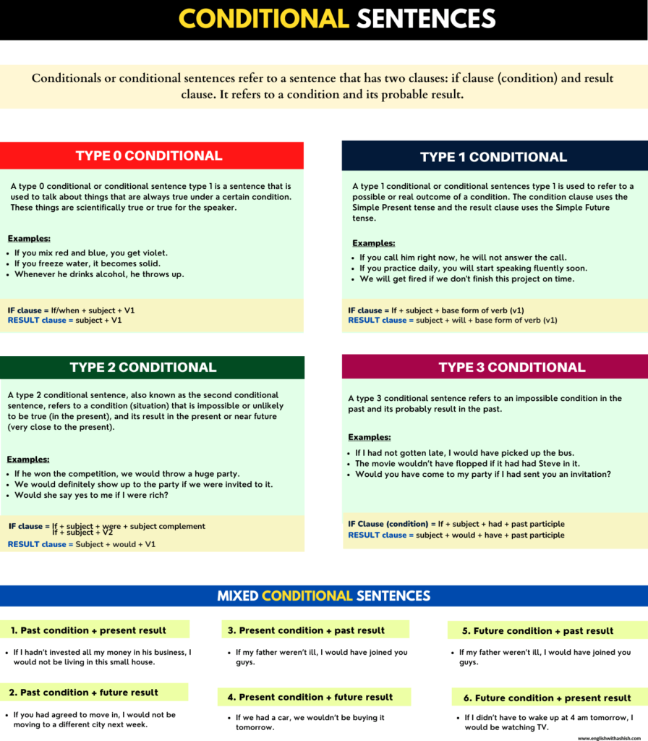

**Types of conditional sentences in English**

These are 4 most common types of conditional sentences in English:

1. Type 0 conditional sentence
2. Type 1 conditional sentence
3. Type 2 conditional sentence
4. Type 3 conditional sentence

|  |  |  |  |
| --- | --- | --- | --- |
| **CONDITIONAL SENTENCES TYPES** | **Meaning** | **STRUCTURE** | **EXAMPLES** |
| **Type 0** | Whenever this happens, that always happens | Condition clause + Result clause  Condition clause (Simple present tense) = If + subject + V1 Result clause (Simple present tense) = subject + v1 | 1. If you freeze water, it becomes solid. 2. When I am upset, I don’t talk to anyone. |
| **Type 1** | If this happens, that will happen | Condition clause + Result clause  Condition clause (Simple present tense) = If + subject + V1 Result clause (Simple Future tense) = subject + will + v1 | 1. If you don’t study hard, you will fail the test. 2. If you see him perform live, you will become his fan. |
| **Type 2** | If this was true for the present, something would happen | (Condition clause) + (Result clause)  Condition clause 1 = If + subject + V2 or Condition clause 2 = If + subject + were + subject complement  Result clause = subject + would + v1 | 1. If I were you, I would take the offer. 2. If she weren’t married, I would propose to her. |
| **Type 3** | If something was untrue (had not happened) in the past, something else would have happened in the past | (Condition clause) + (Result clause)  Condition clause = If + subject + had + past participle (V3) Result clause = subject + would + have + past participle (V3) | 1. If I had not abused my boss that day, he would not have fired me. 2. They would have killed Aman if the police hadn’t reached there on time. |

All types of conditional sentences in English

**Type 0 conditional sentence**

A type 0 conditional sentence *(also known as a conditional sentence type 0)* is a sentence that is used to talk about things that are always true under a certain condition. These things are scientifically true or true for the speaker.

**If you don’t eat food for a long time, you get hungry.**

We, here, have used the type 0 conditional sentence to talk about something that is true under a certain condition. Notice that the result falls true for every human being. Both clauses have used the [Simple Present tense](https://www.englishwithashish.com/present-indefinite-tense-examples/), and the condition starts with ‘if’. Since it comes before the result clause, we have used a comma after it.

Take some ice from a fridge and wait for it to melt. What happens when it melts? **If/when the ice melts, it becomes water.** Now, this is a type 0 conditional sentence. The outcome of the condition (if ice melts) is true for everyone. It does not matter who does it. If you let ice melt, it will become water. It is a scientific fact.

Take red and yellow colors, and mix them together. Do you know what happens when you do it? **It becomes orange when you mix red and yellow together.** It is also a fact, shown by using a type 0 conditional sentence.

**Examples**:

* Snakes bite you when they are scared.
* If you mix red and blue, you get violet.
* If you freeze water, it becomes solid.
* If you drink too much alcohol, your health suffers.

**An event (result) in a certain condition could be true for a person or a group of people.**

* When I am too tired, I hit the bed.
* When I am joyful, I go out and play with kids.
* When Jyoti is ill, she does not talk to anyone.
* Whenever he drinks alcohol, he throws up.
* When Monu eats food, he does not talk to anyone.
* He gets angry if someone starts talking about his ex-girlfriend.
* If you call her after 10 pm, she does not answer it.

Click on [Type zero conditionals sentences](https://www.englishwithashish.com/type-zero-conditional-sentence/) to learn them in detail.

**Type 1 conditional sentence**

A type 1 conditional sentence *(also known as a conditional sentence type 1)* is used to refer to a possible or real outcome of a condition. The condition clause uses the Simple Present tense and the result clause uses the [Simple Future tense](https://www.englishwithashish.com/the-future-indefinite-tense-usages-and-rules/). Here, both the condition and the result are possible and can take place.

**Possible structures:**

|  |  |
| --- | --- |
| If clause (condition) | Result clause |
| Result clause | If clause (condition) |

Condition clause = If + subject + base form of verb (v1)  
Result clause = Subject + will + base form of verb (v1)

**Situation**

I am at a party. Here, I have my friends, relatives, and family members. Most of them are on the dance floor, grooving to the music, and I’m sitting on a sofa at a distance, having fun watching them groove. A bunch of my friends and family members come to me asking me to join them. I, at first, politely refuse to join them.

They keep on insisting, and I lay down a condition in which I will do it. Here’s what I say**:** **If no one records me dancing, I will happily dance with you.**

See, I promise to perform an action under a condition that is absolutely real, possible, and, usually likely to happen or be agreed upon by the party or parties involved.

**If I see you here again, I will call the cops.**

The speaker talks about an action that will take place under a condition. This is not a hypothetical situation; the speaker actually believes that they will perform the action if the condition is met.

Examples:

* If he does not take you in, I will talk to him.
* If Ruchi comes with us on the trip, I won’t go.
* If you say a single word about my job, I will leave right now.
* I will come there if no one smokes in front of me.
* If you don’t study hard, you will fail the test.
* You will have everything you want if you stop wasting time.
* If you don’t get me a bike as my birthday present, I will show your photos to daddy.

**Modal verbs are also used in the result clause to focus on possibility, obligation, permission, certainty, capability, or suggestion/recommendation.**

* If he takes you to Jaipur, you should definitely go to this place called ‘Meerpur’. *(recommendation)*
* If someone tries to attack us there, we can protect ourselves. *(capability)*
* He may bite you if you poke him a little too much. *(possibility)*
* If you don’t invite him to the party, he will be pretty mad at you. (certainty)
* You should call the cops if he threatens you again. (suggestion)

Click on [Type 1 conditionals sentences](https://www.englishwithashish.com/type-1-conditional-sentence-in-english/) to learn them in detail.

**Type 2 conditional sentence**

A type 2 conditional sentence, also known as the second conditional sentence, refers to a condition (situation) that is impossible or unlikely to be true (in the present), and its result in the present or near future (very close to the present).

**Possible structures:**

* (If + subject + were + subject complement) + (Subject + would + V1)
* (If + subject + V2) + (Subject + would + V1)

Examples:

* **If Jon were alive, he would love to see us on the big screen.**  
  (Reality: Jon isn’t alive, and he can’t see us play on the big screen.)
* **We would travel the world if we had a lot of money.**  
  (Reality: We aren’t rich, and we can’t travel the world right now.)
* **If I had her number, I would give it to you.**  
  (Reality: I can’t give her number to you as I don’t have it.)
* **If you studied well, you would pass the test.**  
  (Reality: You don’t study well, and you will not pass the test.)
* **If Jon lived with me, I would not order food online.**  
  (Reality: He does not live with me, and I would have to order food online.)

The condition in a type 2 conditional sentence is either impossible or highly unlikely. That’s why these sentences refer to hypothetical situations. In the first example, the condition is absolutely impossible as a dead person can’t be brought back to life. But the other conditions are not practically impossible; they all are possible but highly unlikely to take place.

**More examples:**

* If I were your mother, I would throw you out of this house.
* If he won the competition, we would throw a huge party.
* We would definitely show up to the party if we were invited to it.
* Would she say yes to me if I were rich?
* If I found a car under 300K INR, I would sell my car and buy it.
* If he weren’t my boss, I would slap him.

Click on [Type 2 conditionals sentences](https://www.englishwithashish.com/type-2-conditional-sentence-in-english/) to learn them in detail.

**Type 3 conditional sentence**

A type 3 conditional sentence refers to an impossible condition in the past and its probable result in the past. We are calling the condition impossible because we can’t go back into the past and change it. What we do using a conditional sentence type 3 is regret what happened or didn’t happen. We do this by laying down the condition in which the reality would have been changed in the past. These are sentences that show your complaints.

**Reality**: I didn’t prepare for the interview, and I did not clear it.  
**Desired result:** clearing the interview (In the past)  
**Condition for the desired result:** If I had prepared for the interview, I would have cleared it.

**Structure**:

|  |  |
| --- | --- |
| IF clause | Result clause |
| Result clause | IF clause |

**Active voice**

**IF Clause (condition) =**If + subject + had + past participle (V3)  
**Result clause =** Subject + would + have + past participle (V3)

**Passive voice**

**IF Clause (condition) =**If + subject + had + been + past participle (V3)  
**Result clause =** Subject + would + have + been + past participle (V3)

**If more people had watched the show, it would not have been closed.**

Reality: The show got closed in the past because of not having much viewership. If the cause of the failure was reversed (imagining), the result (failure) would not have been there.

**Examples**:

* If I had not gotten late, I would have picked up the bus.
* The movie wouldn’t have flopped if it had had Steve in it.
* If I had known that you all went to the park, I would have taken the day off and been there.
* If Rahul hadn’t called the hotel and told them that we were his friends, we wouldn’t have gotten the rooms. *(Giving props to Rahul)*
* If he hadn’t been forced to quit the job, he wouldn’t have done it.
* All the passengers would have been killed if the terrorists had not been given what they wanted.
* Would you have come to my party if I had sent you an invitation?
* If your parents hadn’t parted ways, would you have stayed here in India?

Click on [Type 3 conditionals sentences](https://www.englishwithashish.com/type-3-conditional-sentences/) to learn them in detail.

**We can also use modal verbs in the main clause in conditional sentences**

The modal ‘*will*‘ in the result clause shows the certainty of the action. We can replace it with other modal verbs to refer to other things: recommendation, capability, possibility, obligation,and *permission*.

Examples:

* If someone tries to attack me there, I can protect myself. *(capability)*
* He may bite you if you poke him a little too much. *(possibility)*
* She might marry me if I weren’t broke. *(possibility)*
* You have to forgive him if he apologizes to you. *(obligation)*

**Mixed conditional sentences in English**

A mixed conditional sentence is a conditional sentence that mixes two different times to show a hypothetical situation (condition) and its result. When the condition [clause](https://www.englishwithashish.com/types-of-clauses/)(IF clause) and the result clause refer to different times, the sentence resulting from it is called a mixed conditional sentence.

**1. Past condition + present result**

This structure of a mixed conditional sentence is used to refer to a past condition, and how it would affect the present situation. Remember we are talking about an unreal situation here.

The speaker uses this conditional when they don’t have a certain situation in the present, and a certain condition in the past would produce the desired result in the present.

**If I hadn’t invested all my money in his business, I would not be living in this small house.**

Reality: I am living in this small house because I invested all my money in his business. But if I hadn’t done this in the past, my present would be different.

**If I had not run away from them, I would be working in a factory and drinking alcohol every day.**

Reality: The present is the opposite. I am not working in a factory and drinking alcohol every day because I ran away from them.

**More examples:**

* We would have more jobs today if the government had not shut down those businesses.
* If you had not come from India, they would treat you nicely.
* They would be living with us today if they hadn’t stolen our money.

**2. Past condition + future result**

Here, we show the relation between a certain condition (unreal and unattainable) in the past and an event in the future (the result). The result clause uses future time markers to refer to the future.

**Common future time markers:**tomorrow, next week, next month, next year, later, the day after tomorrow…

**If you had agreed to move in with me, I would not be moving to a different city next week.**

Reality: I am going to move to a different city because you didn’t agree to move in with me. Something that happened in the past has an impact on what’s happening in the future.

**If the company had hiked the wages, the workers wouldn’t protest from tomorrow.**

Reality: The workers are going to protest from tomorrow as the company did not hike their wages.

**If she hadn’t cheated on me, we would be getting married tomorrow.**

Reality: She cheated on me, and we are not getting married tomorrow.

**3. Present condition + past result**

This is another way to talk about a hypothetical situation. Here, a certain condition in the present produces a certain result in the past. But we know the past can’t be changed in the present; what’s done is done, and it can’t be undone. Using this type of mixed conditional sentence is a way to create a hypothetical present situation (condition) and its probable result in the past.

**Imagination: If my father weren’t ill, I would have joined you guys.**

Reality: My father is ill, and that’s why I didn’t join you guys.

**Imagination: if I didn’t have to pay off the loan today, I would have bought the car that day.**

Reality: I didn’t buy the car that day because I have to pay off the loan today.

**4. Present condition + future result**

This is another way to talk about a hypothetical situation. Here in this type of mixed conditional sentence, we use an unreal present condition and its probable result in the future. Here, the present condition produces a future result.

**Imagination: if I didn’t have to pay off the loan today, I would have bought the car that day.**

Reality: I have a high fever, and I won’t come to your party tonight because of it

**Imagination: If my car wasn’t broken, I would pick you up from the airport tomorrow.**

Reality: I won’t pick you up from the airport tomorrow as my car is broken.

**Imagination: If we had a car, we wouldn’t be buying it tomorrow.**

Reality: we are going to buy a car tomorrow as we don’t have a car.

**5. Future condition + past result**

This type of mixed conditional sentence is used to refer to an unreal future condition and its probable result in the past. Here, a future condition is imagined to have had an impact on a past event.

**Imagination: If I weren’t going to Canada next week for a business meeting, I would have attended your destination wedding last week.**

Reality: I didn’t attend your destination wedding last night because of a business meeting that I have in the future. Thinking of the meeting, I didn’t attend your wedding because, by the time I would have gone back from the wedding, my meeting date would have been gone.

**Imagination:**Jon wouldn’t have turned down the fight if he weren’t getting married next week.

Reality: Jon turned down a fight in the past because he is about to get married soon, and he wants to look good on the wedding day.

**6. Future condition + present result**

Another mixed conditional sentence is a combination of a condition in the future and the result of the condition in the present. Here, an unreal condition in the future produces a certain result in the present.

**Imagination: If I didn’t have to wake up at 4 am tomorrow, I would be watching TV now.**

Reality: I am not watching TV right now because I have to wake up at 4 am tomorrow.

**Imagination: I would be extremely sad right now if I weren’t going out for a movie tonight.**

Reality: I am not sad right now because I’m going out for a movie tonight.

**Imagination: We all would be working right now if Jon weren’t organizing fun activities tomorrow on his own.**

Reality: We are not working right now because Jon is organizing fun activities tomorrow himself.

**FAQs**

**What are the 4 types of conditional sentences?**

Here are the four types of conditional sentences in English:  
Type zero conditional sentence (refers to a universal fact under a regular condition)  
Type 1 conditional sentence (refers to a probable/real outcome of a possible condition)  
Type 2 conditional sentence (refers to an unreal or unlikely condition and its result in the present or near future)  
Type 3 conditional sentence (refers to an unreal condition in the past and its impossible result)